The Solar System- Information

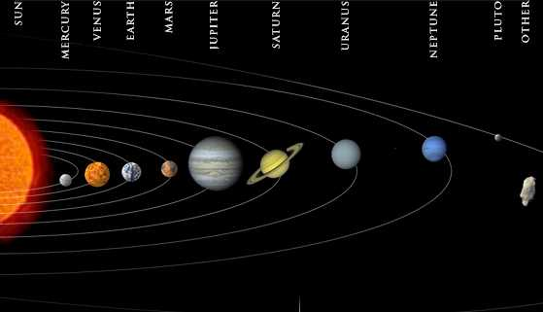

Mercury is a barren rock. It orbits the Sun in just 88 days. The side facing the Sun can
reach temperatures around 700 degrees Fahrenheit, while the side away from the Sun has temperatures of about -330 degrees Fahrenheit.

Venus has thick clouds of sulfur that trap the Sun’s heat and make it the hottest planet in the solar system. It also rotates in the opposite direction as most of the other planets. Of all the planets only Mercury and Venus do not have moons.

Earth is our home and is the only planet we know of (so far) in the whole universe that has life. About 70 percent of Earth is covered in oceans.

Mars is a red planet with very little atmosphere. It is a cold desert with a volcano the size of Utah and a canyon that would stretch across the entire United States. It has ice caps at its poles.

Jupiter is the largest planet and the first of the Gas Giants. It is home to the Great Red
Spot, a storm that is so large that the four terrestrial planets could fit inside. Jupiter also has the most moons of any planet. (We know of sixty moons that orbit Jupiter.)

Saturn is the second largest planet. It has bright rings of rock and dust around it. These rings can be seen through a telescope from Earth. Saturn is also the least dense of the planets. If you could make a cup of hot chocolate large enough to put Saturn in it, Saturn would float like a marshmallow!

Uranus orbits the Sun tipped over on its side and rotates backwards. Like Saturn, it has rings made of particles ranging from10 meters in diameter to tiny piece of dust. However, unlike Saturn, Uranus’s rings are dark and very difficult to see.

Neptune has the fastest winds of any planet in the solar system. The winds of this gas giant can reach 1,200 mi/hr.

Pluto is the smallest, coldest planet in the solar system. It is the only one that hasn’t yet been visited by a spacecraft. Like Uranus, Pluto orbits with its poles almost in the orbital plane.

