Solar System Quiz
1. Which planet is the closest to the sun?
a) Pluto
b) Mercury
c) Earth
d) Jupiter
2. Which is the largest planet?
a) Saturn
b) Pluto
c) Earth
d) Jupiter

3. Which planet has the brightest ring system?
a) Saturn
b) Neptune
c) Jupiter
d) Uranus

4. If the image of a planet seen through a telescope looks like a smooth disk, it is because the planet is
a) covered with clouds
b) very smooth
c) too far away to see details
d) any of the above

5. How can we distinguish planets from stars, using our unaided eyes?
a) planets don't twinkle
b) planets move in different ways than stars
c) they are present in the sky at different times than stars are
d) all of the above

6. Tell how one planet got its name.

7. Name one thing that ancient astronomers knew about planets.
8. Look at this image of a planet: 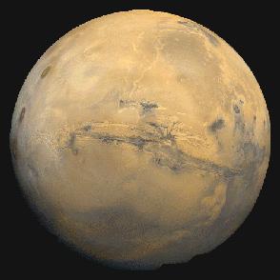
Why is it NOT Saturn?

Why is it NOT Jupiter?

Why is it NOT Neptune?

Why is it NOT Earth?

